Transfer Letter

To 18/03/2020 K S Enterprises,
73, Narayanrao Koli Marg,
Masjid Bunder (W),
Mumbai 400003

Dear Sir,
Sub: Transfer Letter of Import License No. 0310737816 Dt. 17/06/13
for US $ 33,159.00 , Indian Rupees 24,62,056.00
Of M/S RAMA EXPORTS
For Import of AS PER IMPORT ITEM LIST

We hereby transfer the above Import License in your favour in terms ______ of para of import policy ________ you will import the goods as mentioned above strictly as per import policy in force and in the event of any Penalty / Damage or loss on account of misutilization if any made by you or your transferee. You will be fully responsible for the same & we do not own any liability or responsibility for the same.

We have received full and final compensation for transferring the above License.

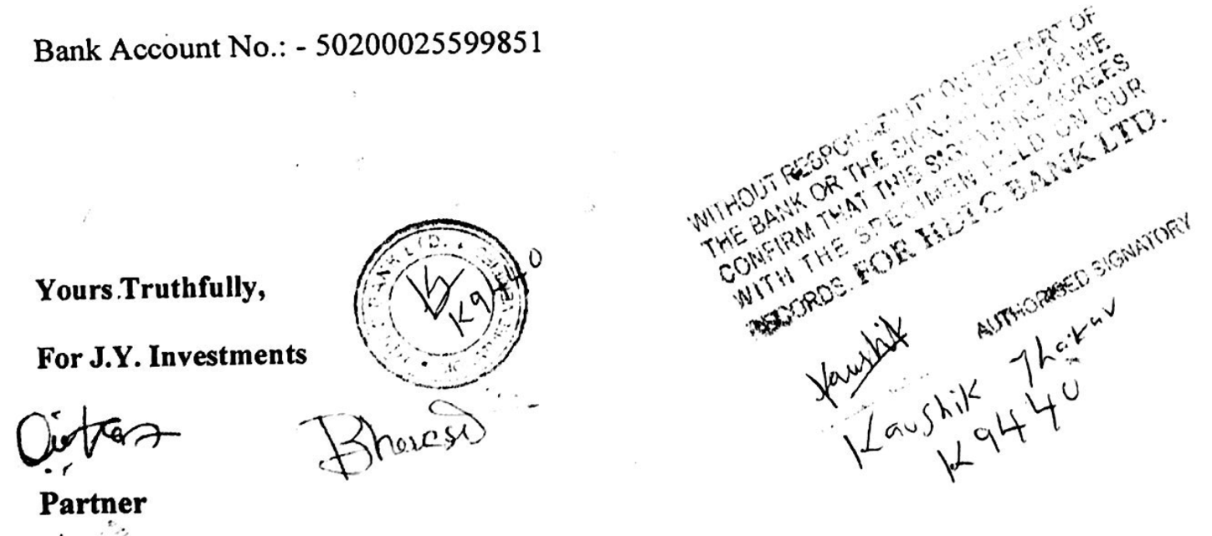

Transfer Letter

To 18/03/2020 J.Y. Investments,
302, Jura Palace,
Liberty Garden Road No3,
Near Nana Shankar Sheth Chowk,
Malad West, Mumbai 400064.

Dear Sir,
Sub: Transfer Letter of Import License No. 0310737816 Dt. 17/06/13 for US $ 33,159.00 , Indian Rupees 24,62,056.00
Of M/S RAMA EXPORTS
For Import of AS PER IMPORT ITEM LIST

We hereby transfer the above Import License in your favour in terms ______ of para of import policy ________ you will import the goods as mentioned above strictly as per import policy in force and in the event of any Penalty / Damage or loss on account of misutilization if any made by you or your transferee. You will be fully responsible for the same & we do not own any liability or responsibility for the same.

We have received full and final compensation for transferring the above License.

